SADIE Research Instrumentation Under Development

The current SADIE (Subtle Energy Administration & Interpretation of Human Electromagnetics) Prototype Instrumentation in Development consists of a Laptop Computer with a National Instruments (NI) Data Acquisition Card (DAQCard) inserted into the laptop computer’s PCMCIA slot, National Instruments LabVIEW software for measurement and analysis, LabVIEW Advanced Signal Processing Toolkit, DIAdem – Interactive Data Analysis and Report Generation Software, custom bio-amplifier, special measurement, and cable interconnect boards, and medical isolation power sources or batteries. Reference the SADIE Instrument Block Diagram.
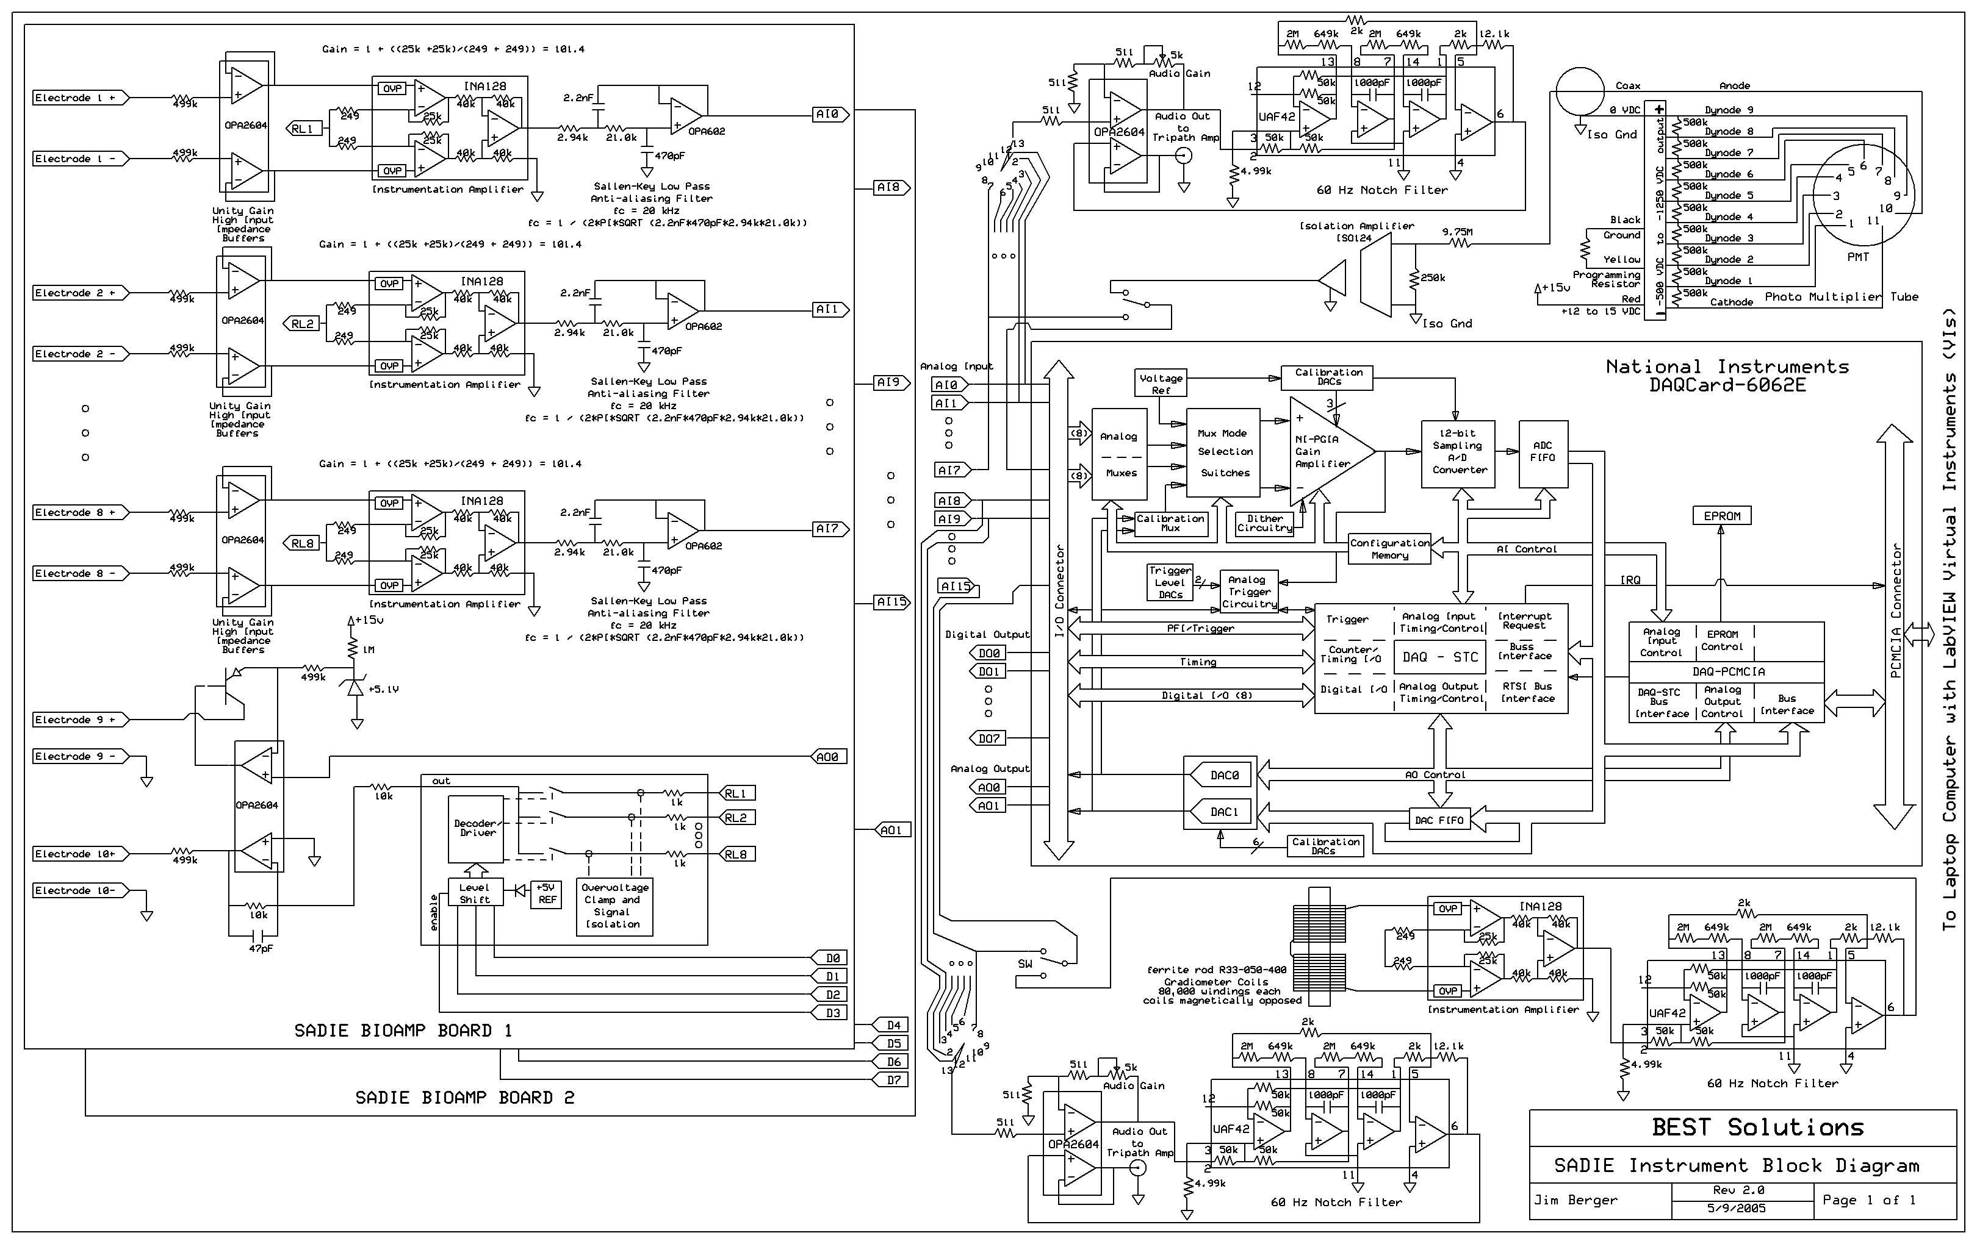

SADIE BioAmp Boards 1 and 2 are identical and allow two subjects to be tested simultaneously, with up to 8 differential measurements per subject, or if just one subject up to 16 differential measurements. The bio-amp boards connect back to an interconnect board for further routing by a 20 foot ribbon cable to each board. The boards are small enough to fit into a standard portable CD player carrying case that can be conveniently strapped to the subject’s waist or hung from a shoulder strap.

Standard snap-on ECG leadwires with banana plug terminations plug into the front end of the board. Initial tests will be performed with standard ECG or Stress Test type disposable electrodes.

Each bio-amp board has eight differential input bio-amplifier circuits. At the front end of each bio-amp, a 499k ohm resistor is in place to limit any fault current back to the subject to about 30 microamps. Texas Instrument/Burr Brown (TI/BB) OPA2604 OpAmps configured as unity gain high input impedance buffers feed the differential signal into a TI/BB INA128 Instrumentation Amplifier set for a gain of approximately 100 and connected such that the common mode signal can be sent back to the subject if so selected, similar to the Right Leg (RL) drive common on many electrocardiogram instruments. The amplified signal from the instrumentation amplifier is then fed into a 2 pole Sallen-Key low pass Butterworth response type anti-aliasing filter with the 3 dB cutoff frequency set for 20 kHz, to promote accurate digital processing by the DAQCard.

The common mode voltage from each of the 8 instrumentation amplifier inputs is fed into a TI/BB MPC508 Multiplexer. The 8 amplifiers are typically read in succession and the software is programmed to select and feedback the currently read instrumentation amplifier’s common mode signal to the right leg or another chosen feedback point on the subject’s body. The feedback signal is 180 degrees out of phase with the original signal to cancel out the common mode voltage of the differential measurement, such that the differential voltage can more clearly be read. Typically only the Electrode 10+ (and not the Electrode 10-) is connected back to the subject’s body. A 499k ohm resistor is in line with the Electrode 10+ lead to limit the current back to the subject to 30 microamperes.

The final circuit on the bio-amp board output to Electrode 9+ allows the researcher to inject various signals into the body. With the NI DAQCard-6062E, any waveform with a frequency 0 to 50k Hz (50,000 cycles/second) can be created. Some studies I will personally conduct on myself, will be to chart the frequency response of the various branches or channels of the acupuncture-meridian system. For a normal body impedance of about 1 M ohm (1,000,00 ohms) I can adjust the voltage from 0 to about 3 V peak to peak. Also if any 2 electrodes breach the skin’s resistance, which can drastically drop the body’s resistance from 1 M ohm down to about 500 ohms the maximum current will be limited to about 10 microamperes by the 1M ohm in series with 499k ohm resistors since the typical board voltage will be +/-15 VDC by medically isolated power supply or +/- 12 VDC if operated by batteries.

The National Instruments DAQCard-6062E fits into one of the PCMCIA buss slots of my COMPAQ Presario 3000 laptop computer. This DAQCard can read up to 16 single-ended or 8 differential signals. Note that the SADIE bio-amp boards convert a total of 16 differential signals into 16 single-ended signals while amplifying the signal by 100 times. The DAQCard-6062E has a maximum sampling rate of 500,000 (500k) Samples per second. To resolve a complex waveform you need to sample the waveform at least at 10 equally time spaced points along the waveform and preferably at 20 points. This means that if I am reading just one channel I can distinguish waveforms at frequencies up to 50kHz fairly good and up to 25kHz very good. If I am looking at 2 channels, for instance 1 set of electrodes reading the differential signal from front to rear of the body in the area of the heart charka of the healer and make the same measurement with the 2nd bio-amp board on the healee, I could read the 2 waveforms almost simultaneously at frequencies up to 25kHz fairly well and up to 12.5kHz very well. What this means is that we can read one channel each on 2 subjects with fairly good resolution (12 bit analog to digital conversion) well within the range of frequencies measured by Dr. Valerie Hunt, and documented in her book “Infinite Mind”. By similar calculation, if we wish to read all 16 channels close to simultaneously, we can read 50kHz/16 = 3.125kHz waveforms fairly well and 25kHz/16 = 1.56kHz waveforms very well. According to Dr. Hunt’s work, the first level of the human energy field was in the 200 to 1.2kHz range. Therefore to measure higher levels of the human energy field we must limit our tests points or read two channels successively at time when all possible electrodes are being monitored (missing data while other channels are read).

The 8 digital input/output (DIO) lines of the DAQCard are used as digital outputs to programmatically select the correct instrumentation amplifier’s common mode voltage to feedback to the subject.

The 2 DAQCard analog outputs are used to drive the 9th electrode terminals via a voltage controlled current waveform (limited to 10 microamperes maximum) at frequencies up to 50kHz. A question I have pondered over the past few years, is whether I can chart the frequency response of the acupuncture-meridian energy channels. Are there medically significant differences in the frequency response and signal amplitude for a given input signal when comparing healthy and diseased subjects? Can I measure blockages in the energy channels that correlate to the location of a cancerous tumor? Can I more effectively carry a frequency at the mortal oscillitory rate of the cancer and kill the microorganism that may be the cause or at least a symptom of the disease? The ideas? Just keep coming.

Refering back to the SADIE Instrument Block Diagram, there is additional circuitry above and below the NI DAQCard-6062E block on the diagram. A rotary switch is used for each bio-amp board to select one channel at a time to further amplify the signal, filter out as much 60 hertz noise from the environment as possible, and then send the signal to an audio stereo amplifier with two speakers to play back in real time the electrical activity from the human body or 2 bodies at once when connected. Dr. Valerie Hunt claims to be the first to record the music of the charkas and the human energy field. We will attempt similar recordings with the SADIE Instrument.

There is a second switch for the 8th channel of each bio-amp board to do other types of measurement. In the upper right hand corner of the block diagram, is a circuit I am hoping will allow us to read photon emission from a subject. I have some type 931A, 931B (visible light spectrum) and 1P28 (visible and ultraviolet light spectrum) photomultiplier tubes. If the light is measureable, I also have various colored filters from which we could possibly distinguish specific colors. Then with the help of an independent person (Gail Cox) capable of reading auras (as did Rosalyn Bruyere for Dr. Valerie Hunt’s experiments) we can determine if there is any correlation between the instrument’s readings and the aura readings. Note that the photomultiplier tube socket converts 15Volts DC to -1250 Volts DC to drive the tube. This circuit is isolated from the other circuitry by using a separate medically isolated power supply and a TI/BB ISO124 Isolation Amplifier to safely send the output signal back to the computer for processing.

The lower circuit that can be switched in on the second bio-amp board is a magnetometer with 2 each magnetically opposed 80,000 turn coils mounted on a ferrite rod. Calculations show that I could possibly measure magnetic fields in the pico-tesla (10^-12) range, and therefore the magnetic field of the heart. The magnetically induced current in the coils is amplified by a TI/BB INA128 instrumentation amplifier and then sent through a 60 Hz notch filter to eliminate as much 60 Hz noise as possible before sending the signal back to the laptop computer for further processing. As an alternative, until I figure out how to wind the coils properly, I can connect in an F.W. Bell Model 5080 Gauss/Teslameter, that will allow me to read down to the nano-Tesla (10^-9) range.

This past weekend I built a circuit to test the various channels of the bio-amp boards for frequency response and range. My DAQCard-6062E was sent back to National Instruments for recalibration about a month ago. Over the next couple evenings I will be writing software to send a sine wave or square wave out through channel 9 of the bio-amp board, reduce the signal down to the millivolt range to correspond to the bodies electrical levels and feed the signal back into the other channel analog inputs, recording the frequency response and range, and proper common mode voltage feedback. If I can get that done by Friday night, then on Saturday and Sunday I will focus on the measurement, analysis, and report generation from measurements off my body. Then come next Monday morning May 16, we will be prepared to perform our first research experiments at the University of Wisconsin, Milwaukee shielded room.

