Ovarian Cancer approx 5 years after diagnosis

Treatment on AZ-58 Semi-Solid State RF Generator, Scoon Audio Frequency Booster Amp, Computer w/LabVIEW software/National Instruments Data Acquisition Board, Super-Regeneration Simulation software, Bill Cheb 5” hand-held phanatron tube

Typical Blood Smear photos 1 hour after treatment
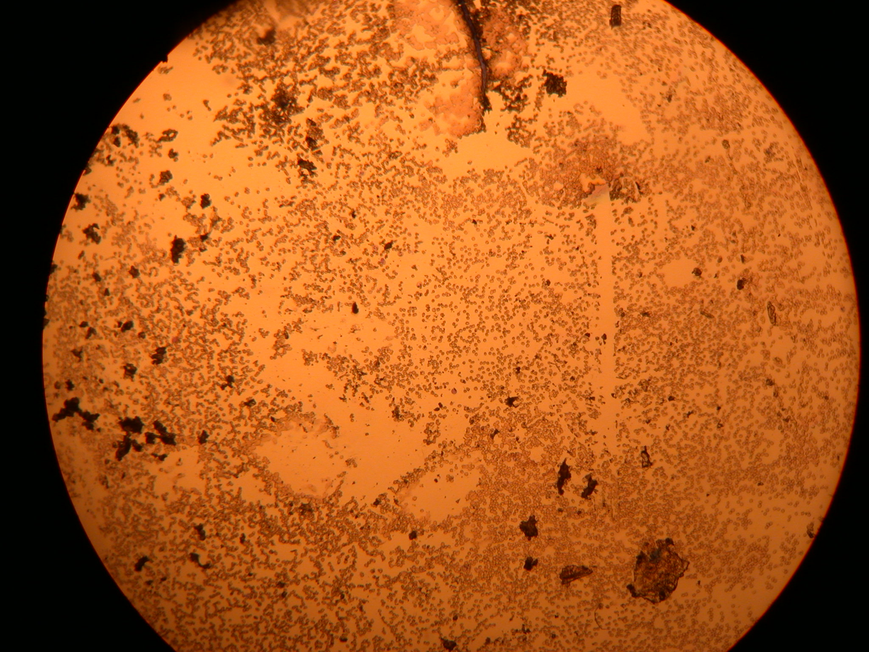

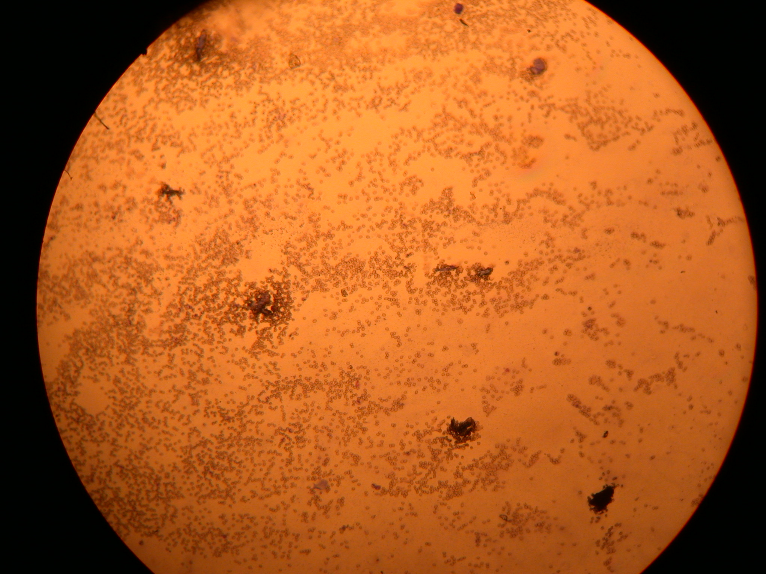

Typical Blood Smear photos 8 hours after treatment
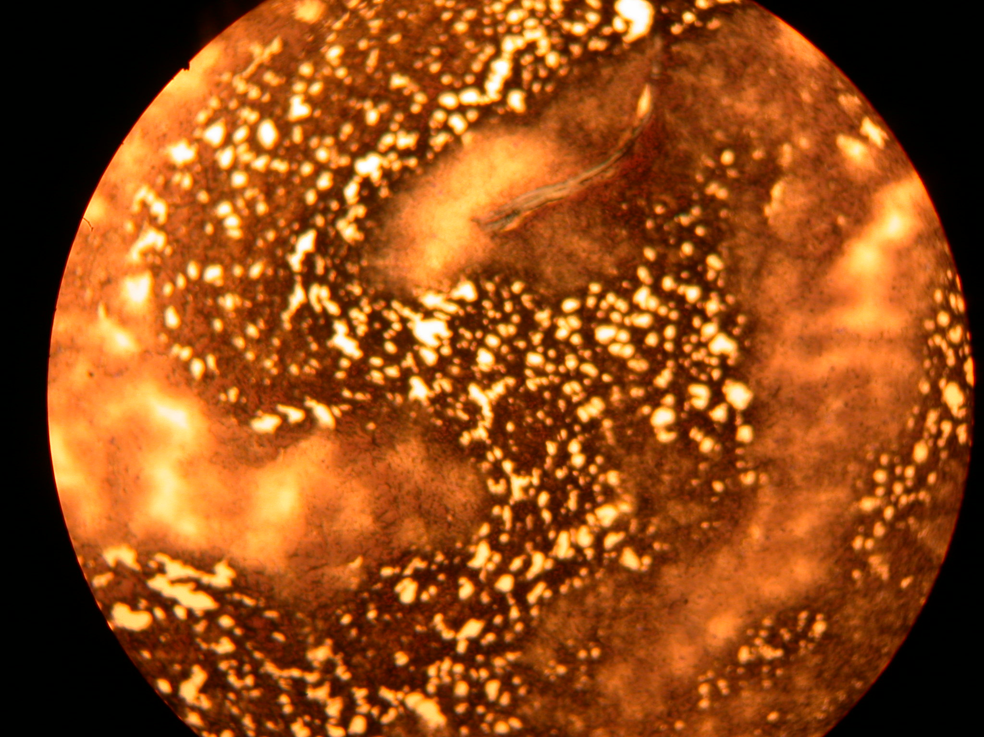

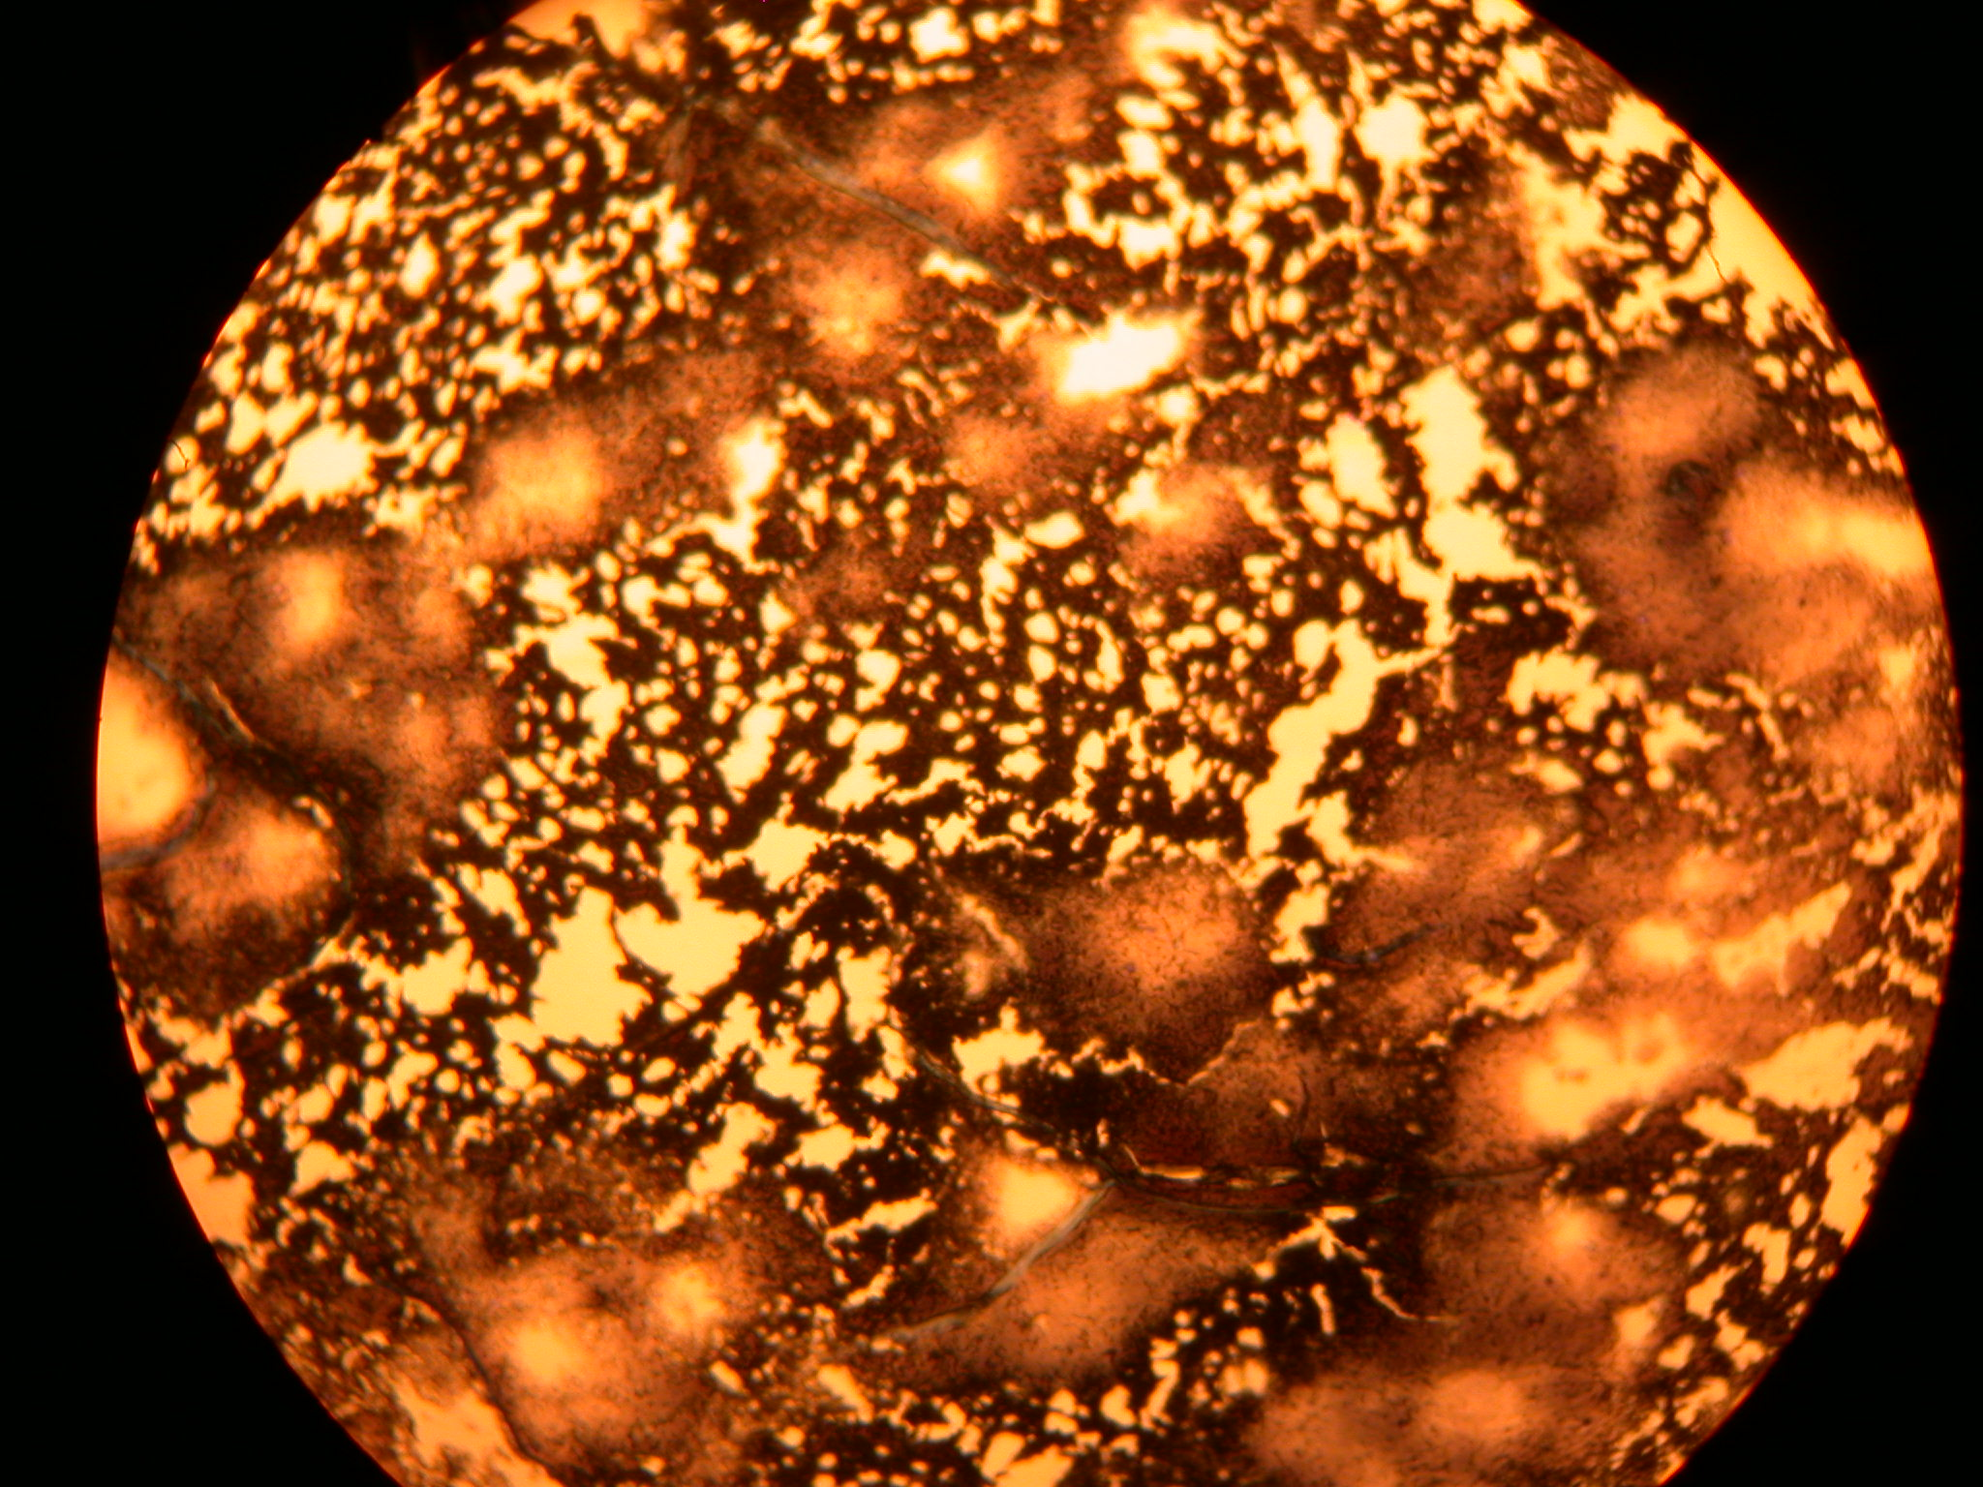

Typical Blood Smear photos 16 hours after treatment
